Assignment 7 Reflection:

All of the requirements for Assignment 7 are complete.

My biggest issue with this assignment was really figuring out the logic in order to make it work. I did base it off of the outline that was provided, but have a variation in the print() method which represents the printer queue/spooler. Rather than having a tick() method that would simulate the passing of a second when a new print job is being dequeued, a task gets dequeued within the print method, cause the passing of a second.

Hopefully I executed this program to function as you are expecting… If not, please let me know what I may have misread/miscoded. Thanks!

**Simulation.java**

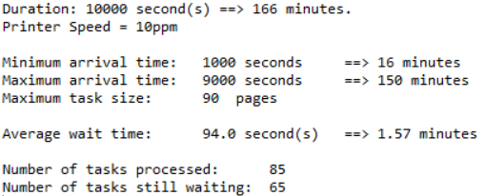

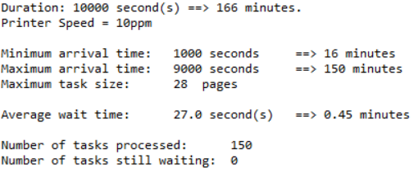

There wasn’t much as far as tests cases for this simulation. Because half of the variables were hard coded and the other half were random numbers (including preconditions to ensure the random numbers were valid) the methods had to process the numbers. By looking at the output, it is obvious that it is working